Assignment # 2 - Write html code using semantic tags

Tasks to complete:
Create a start page that you will use as the default page in your browser. Include the following items in this start page:
Note: Refer to below mentioned wireframe.
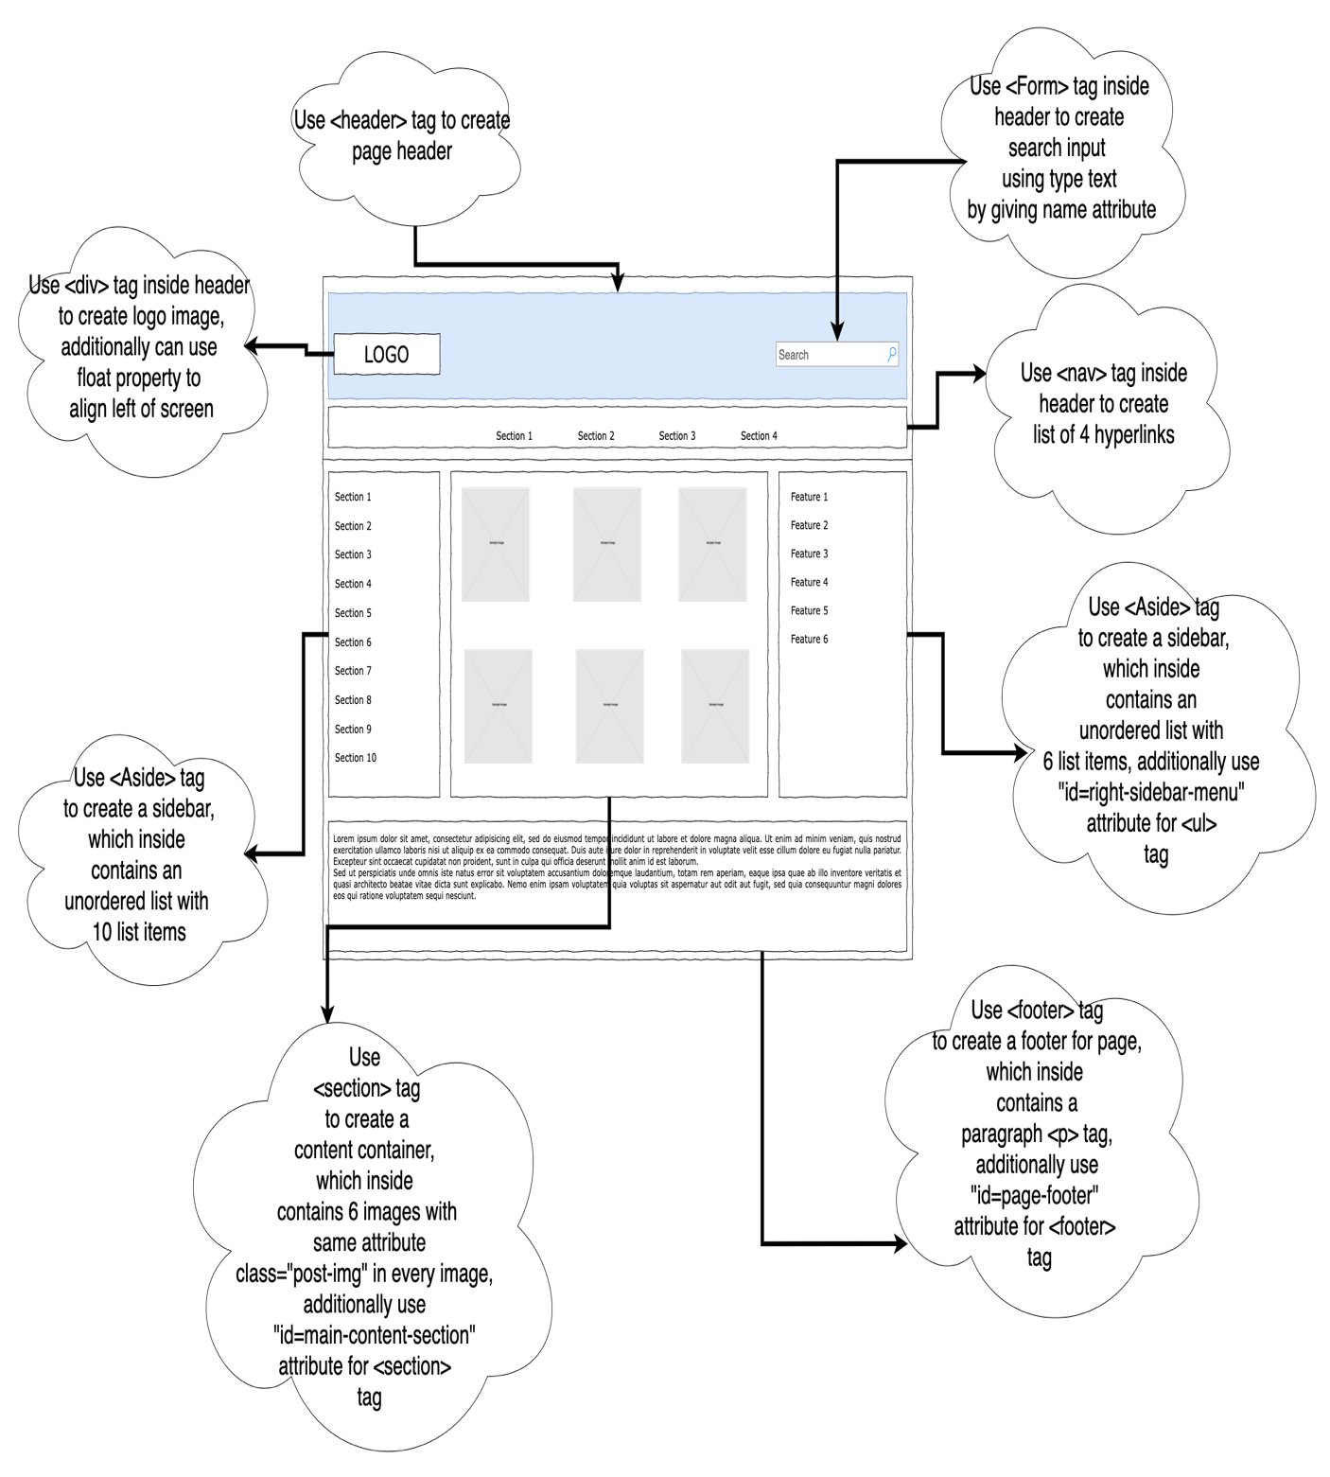
Note: Follow the step in ReadMe file to run test cases.

Submission Steps
- Login into Github account using your crentials.
  - Click on new button
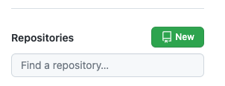
  - Click on “Import a repository”
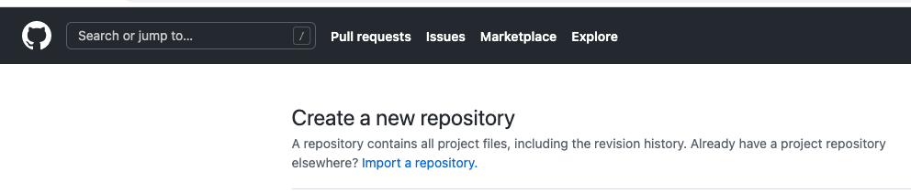
  - and Paste the URL https://github.com/the-10x-academy/HTML-CSS-Assignments.git
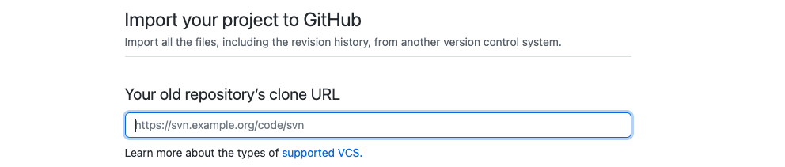
  - Please keep you Repo Name and click “Begin Import”
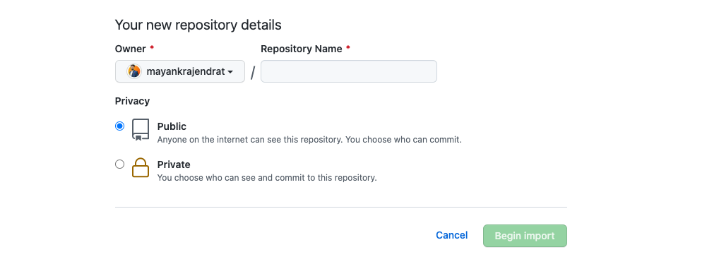

- Git Clone in Fresh and Empty folder by copy URL from Repo that create in Step 1 -

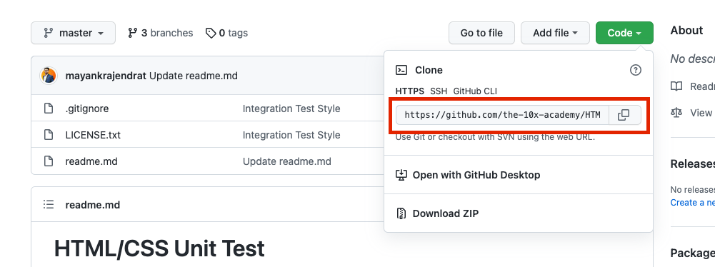

git clone 'URL'

- Open you Repo in VSCODE and in terminal type cd "Repo name”.
  - If you cloned already the repo Please follow below mentioned commands
git fetch https://github.com/the-10x-academy/HTML-CSS-Assignments.git master
  - git cherry-pick FETCH_HEAD

- git checkout -b "BranchName"
Note: Branch Name should be the Assignment Number for example : Assignment 2, command would be
git checkout -b Assignment-2

- Start making changes in assignment2.html and assignment2.css.
- Proceed with Staging using command git add . or use Vs code extension
- Git commit or use Vs code extension
- Git Push or use Vs code extension
- Create the Merge Request as mentioned in below screenshots.
  - Select the branch that checkout in step 4
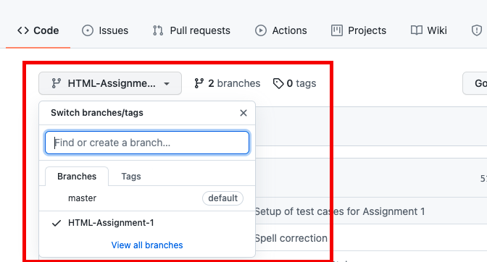

  - Click on “Pull request”
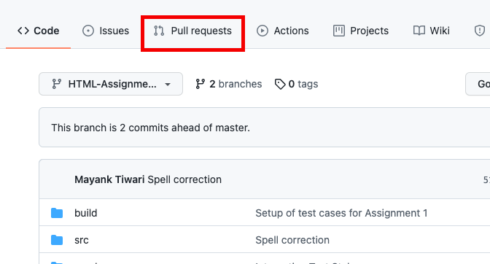
  - Click on “New Pull Request”
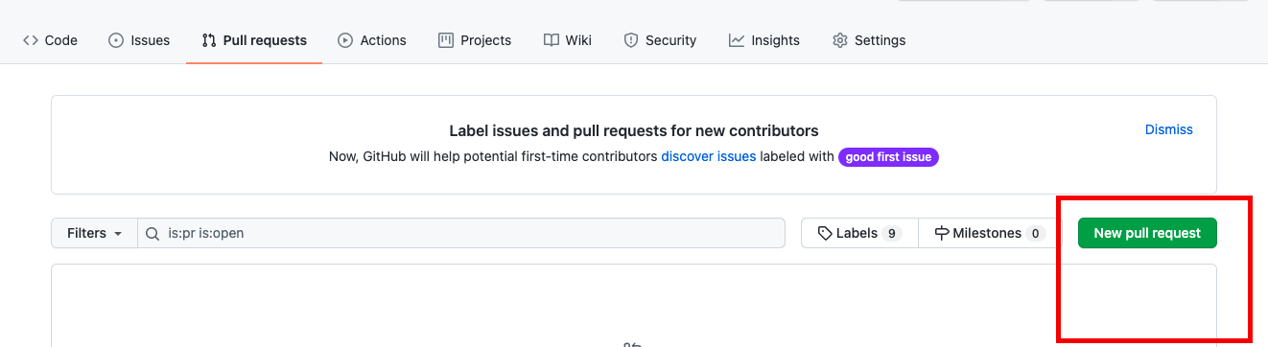

  - Select the branch that checkout in step 4
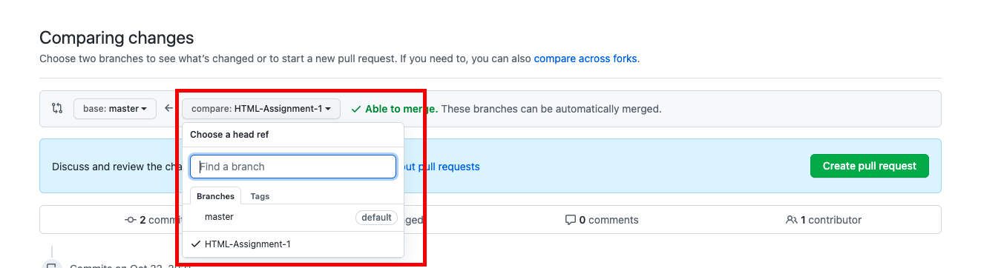
  - Create a pull request and share link of Request as your submission.
Please take screenshot of final output from your browser and keep in Pull Request description.
Share the Branch URL: https://github.com/{Username}/{Repo Name}/ pull/{Request Number}
